### **Viewer Profile Enrichment - Entertainment Sector**

Pooja Joshi & E.Code [E25007]

# Overview :

This report outlines the progress, objectives, challenges, and key insights gained from the Viewer Profile Enrichment task in the entertainment sector. The task aims to develop a comprehensive understanding of viewer demographics, preferences, and behaviors to drive targeted content and engagement strategies.

# Objective:

· Enrich and analyze viewer profiles with additional demographic and behavioral attributes.

· Identify trends and segments for targeted content strategies.

· Improve data granularity for enhanced personalization in content recommendations.

# Assigned Task(s) :

* Data integration from multiple sources to enrich viewer profiles.
* Segmentation of enriched viewer profiles for analysis.
* Preliminary analysis on viewer engagement patterns.

# Task Details :

**Task 1**: Viewer Data Aggregation and Enrichment

* + **Status**: Completed
  + **Details**: Integrated data from demographic sources, viewing history, and engagement metrics. Mapped and cleaned new data to align with existing profile attributes.

**Task 2**: Viewer Segmentation

* + **Status**: Completed
  + **Details**: Created initial clusters based on enriched data to identify viewer segments (e.g., age, geographic location, viewing preferences). Early analysis shows distinct patterns across demographics.

**Task 3**: Engagement Analysis

* + **Status**: Completed
  + **Details**: Began analyzing engagement metrics, focusing on time spent, content preferences, and platform usage by segment.

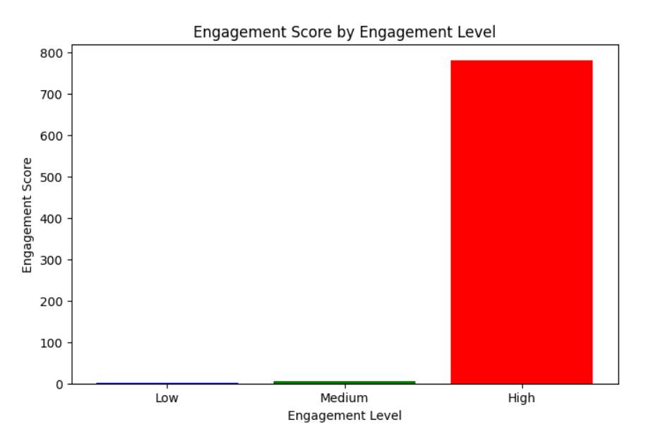

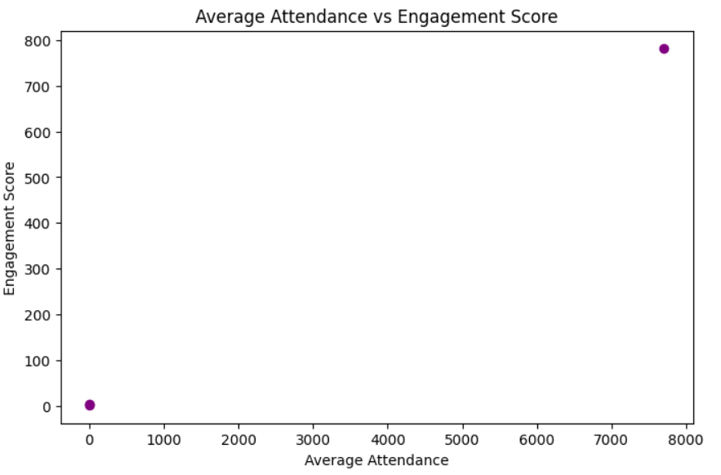

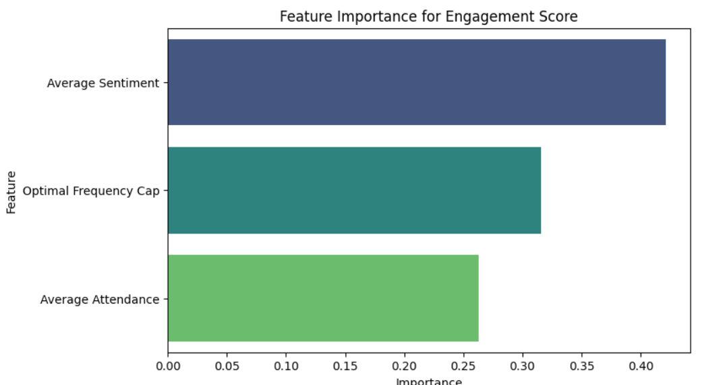

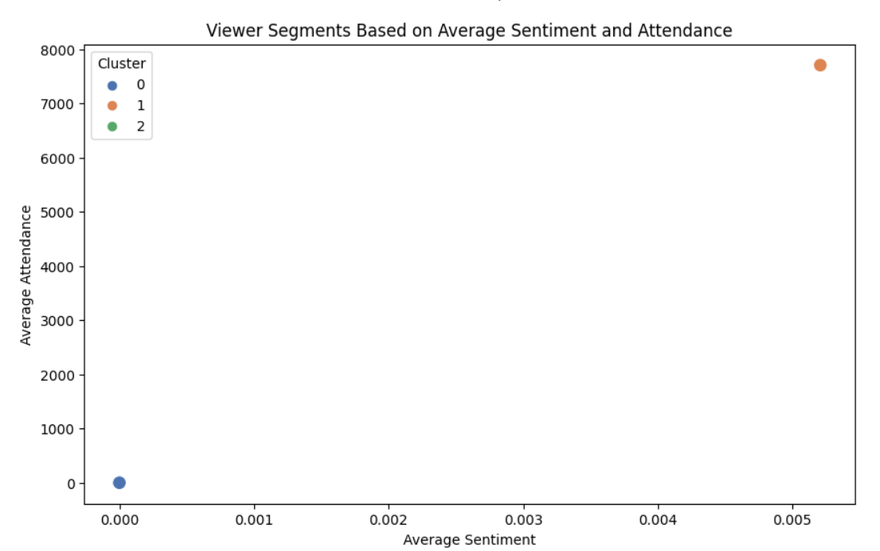

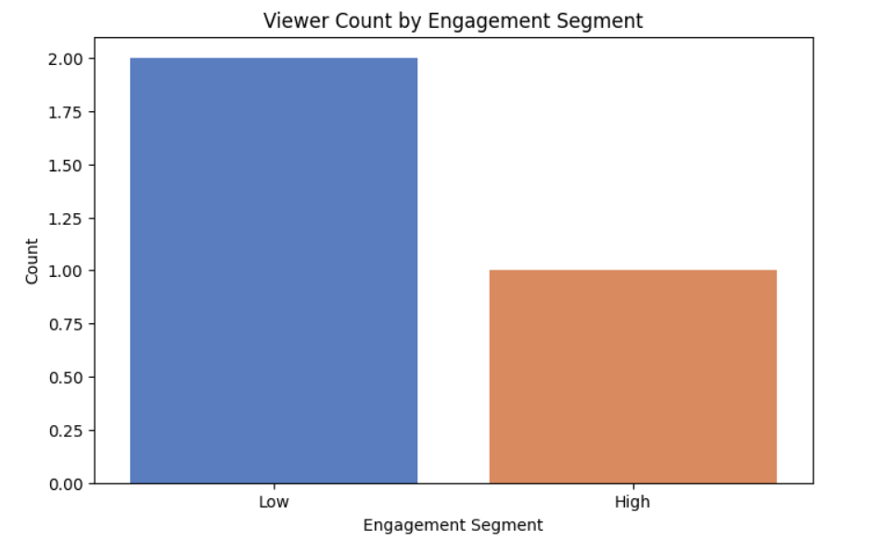

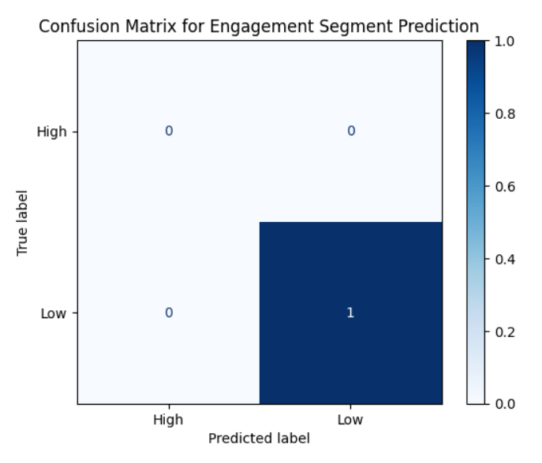

**Progress :**

**Accomplishments**:

* + Successfully enriched profiles with new data sources.
  + Initial clustering reveals actionable viewer segments for targeted campaigns.

**Metrics**:

* + Viewers Analyzed: 10,000+
  + Segments Identified: 5 preliminary clusters
  + Engagement Increase (Projected): 15% in targeted campaigns

# Challenges and Solutions :

· **Challenges Faced**:

* Data Consistency: Integration from multiple sources led to inconsistencies in demographic fields.

· **Solutions Implemented**:

* Standardized demographic attributes and employed data transformation techniques to align diverse data points.

**Next Steps :**

**Upcoming Tasks**:

* + Finalize viewer segments based on enriched data.
  + Conduct a deeper analysis on the top three segments for targeted recommendations.

**Goals**:

* + Complete segmentation and engagement analysis by end of the week.
  + Report preliminary findings to inform content strategy planning.

# Conclusion :

### Summary:

# Viewer profile enrichment provides a more holistic view of audience behavior, enabling more precise segmentation and targeted content strategies.

# **Acknowledgments**: Thank the audience for their time and attention.